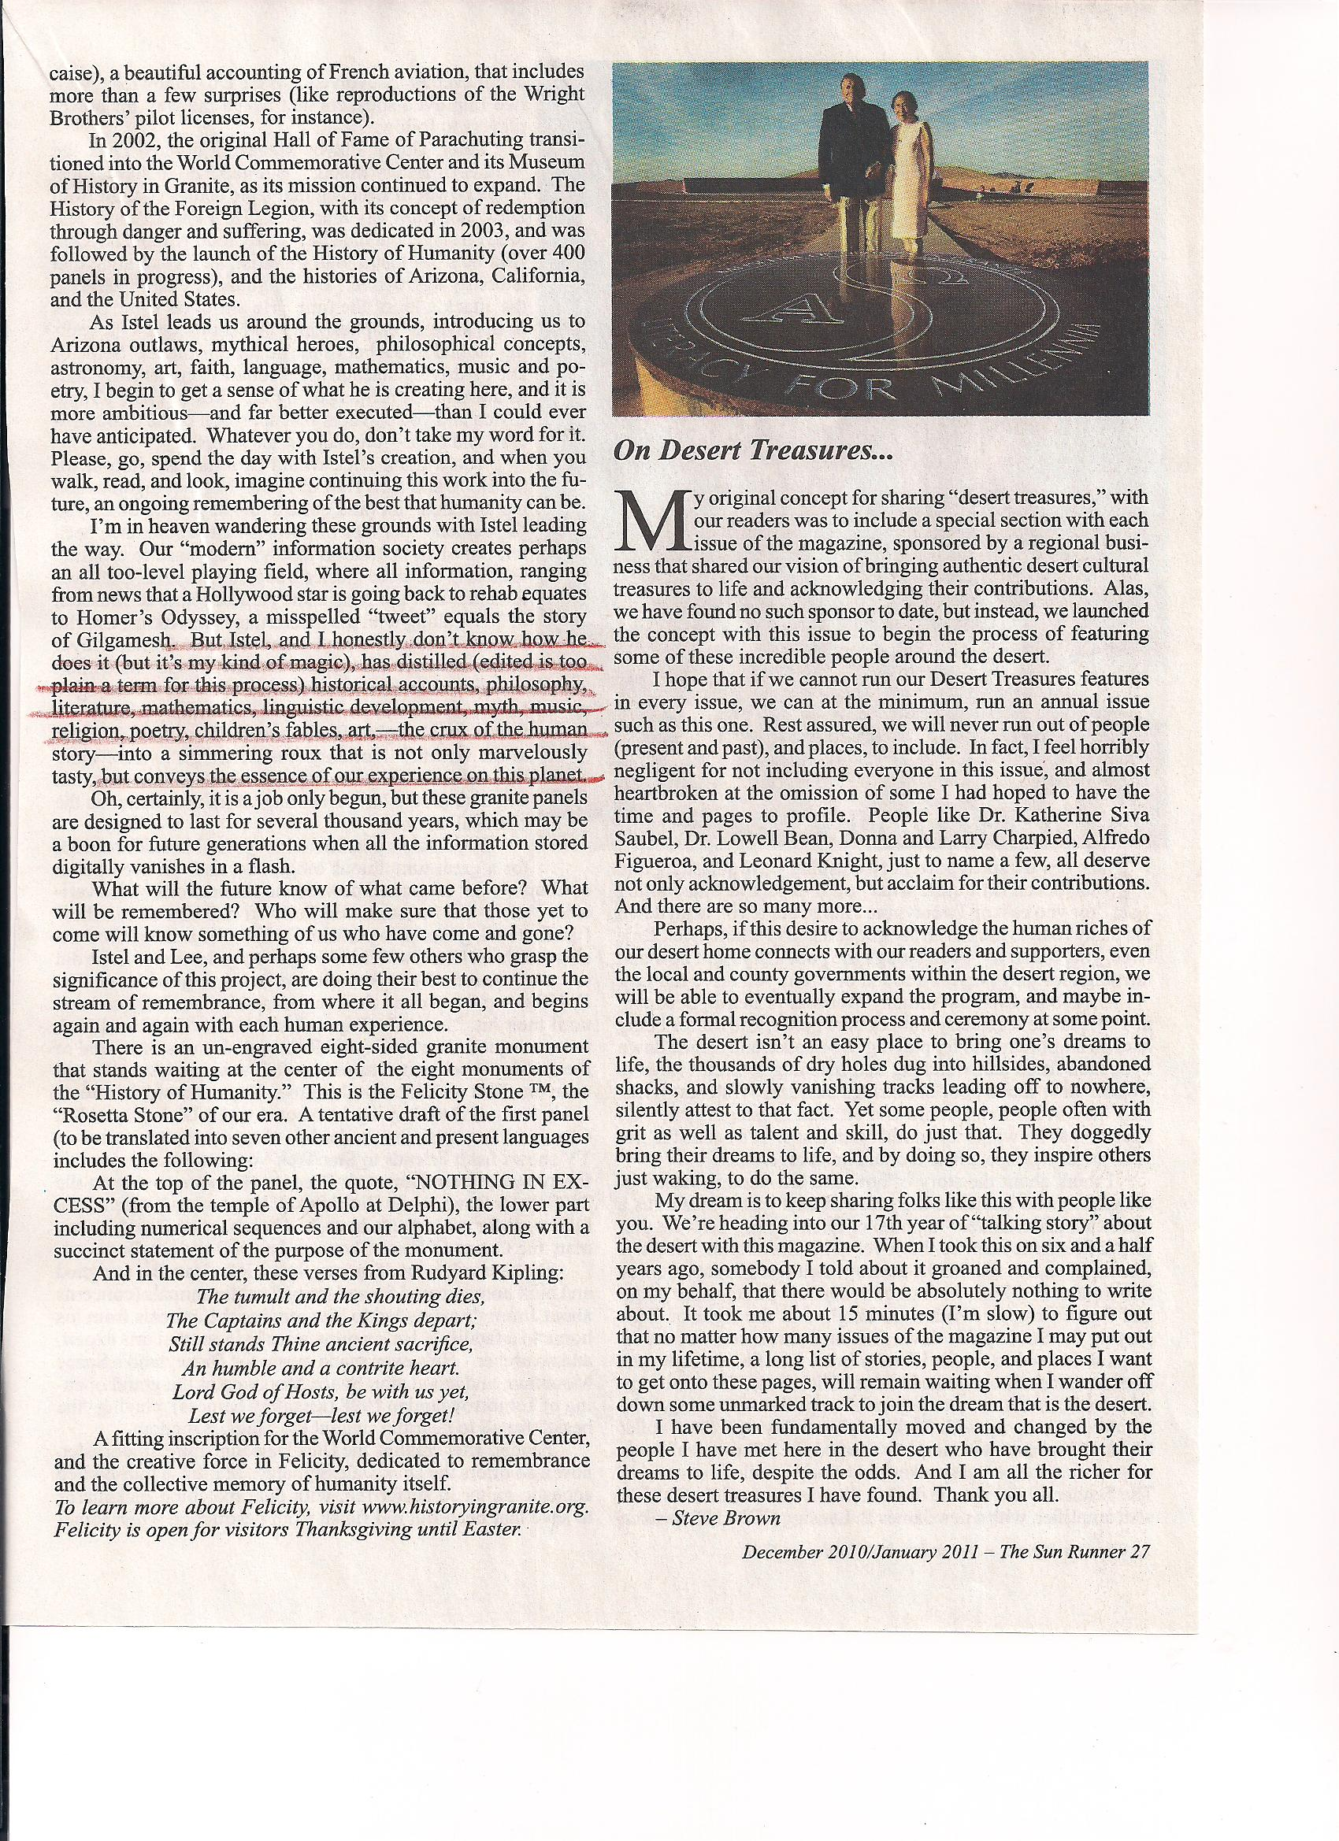

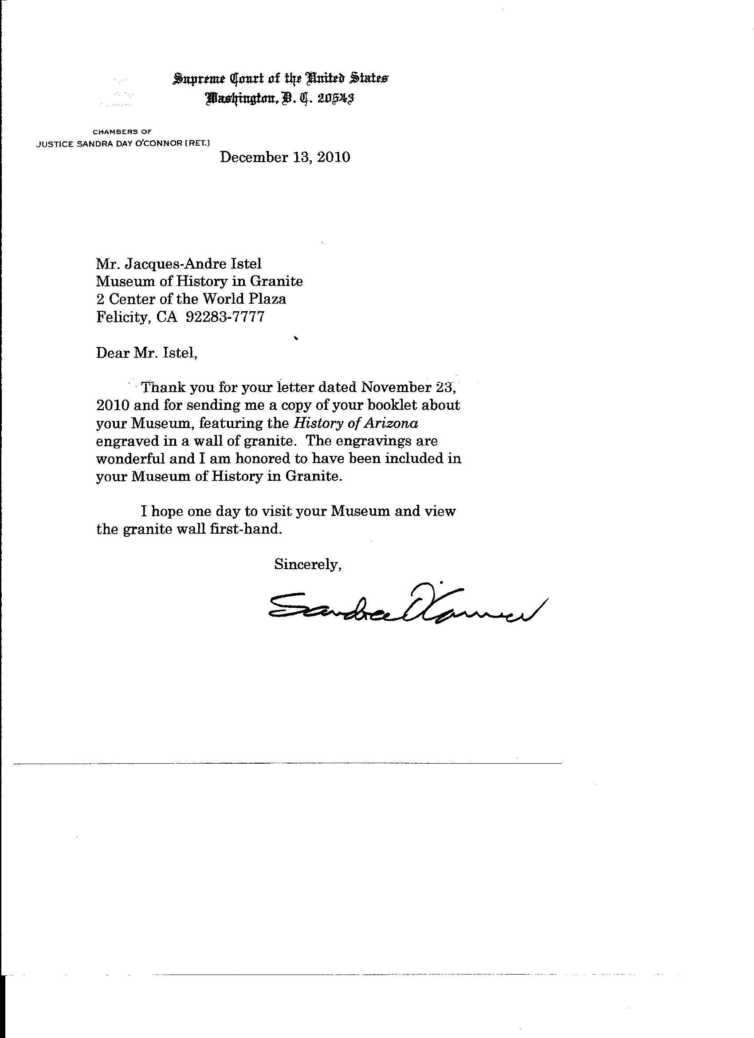

Hi Jacques-Andre,

Nick DiGiovanni commented on Jan Meyer's video.

Nick wrote: "I know, John. I first met Jacques in the late 1970s while high on mushrooms and I thought he was a god, and thank goodness I was right .

6 Jan 2011

Hi Jacques-Andre,

Jon Guignard commented on Jan Meyer's video.

Jon wrote: "A ground breaking pioneer skydiver, Marine, and great story teller! Thanks Jan. I've watched it several times already."

-----Original Message-----  
Date: Sun, 27 Feb 2011 23:47:55 -0500 (EST)  
From: Dale@amblertravel.com  
To: feli2u@aol.com  
Subject: Re:  Your visit on 13 February

Hi Felicia & Jacques:

Just returned from an 8-day COLONIAL MEXICO program.  It's was another exceptional AMBLER adventure in travel.  It was great to see you and Jacques once again.  Everything was great and I appreciate your extra effort to make us feel so welcome and special.  The CAKE was impressive and made a statement to our participants.  Even though our paths don't cross often enough, whenever I think of Jacques and Felicity my heart puts on its happy face.

Be sure to let me know the next time you come to San Diego so I can roll out the red carpet.

Thanks again and AU REVOIR for now!

Dale

On Thu, Feb 24, 2011 at 1:48 PM, Feli2u@aol.com wrote:

 Dear Dale:

Thank you again for bringing your lovely group to Felicity.  We hope  they were pleased with their experience here and found the meal  acceptable.

Thank you and Joanne for your donation to the Hall of Fame of  Parachuting.  Your names will be engraved on the Wall for the Ages next  fall.

Have a good summer and until we meet again, thanks and all best  wishes,

Jacques, Felicia, Debbie, Jessica and Carolyn

From: libbymcclintock@gmail.com  
To: ctrworld@aol.com  
Sent: 2/13/2011 9:46:57 A.M. US Mountain Standard Time  
Subj: afterthoughts

dear jacques and feli,  
  
no digital images could have prepared me for the tranquil, lofty  sensation of standing among the walls and looking up at the church.  
  
i knew you were doing something extraordinary but i did not expect to be so moved and so inspired.  
  
and quite apart from what you are doing there, i will remember the warm, cozy pleasure of sitting in your big bedroom with you two happily tucked up in bed.(NOTE reference is to our French habit of breakfast in bed.)  
  
i am so glad i came to see you.  
  
much love,  
  
libby=

BELOW IS AN ANTI-KUDO

In a message dated 3/31/2011 11:32:40 A.M. US Mountain Standard Time, calpl8z@boal.net writes:

thank you. actually I am trying to know what quantity an “edition” is. I read the book, and have chosen not to read it to my 300 2nd graders. It seems more like an advertisement for your center of the world site than a meaningful children’s book. However, nicely written and illustrated. Perhaps you can share with me an actual quantity that makes up an “edition”. John boal, Upland CA

Perhaps you can share with me an actual quantity that makes up an “edition”. John boal, Upland CA

AND OUR PROMT ANSWER

Dear Sir;

We have never asked, or even suggested to teachers that they read the book to students.

Some teachers on their own accord  have chosen to do so, and we were moved by letters from their students, some of which you may have seen on exhibit at Felicity.

We respect your opinion and point out for the record that the continuation of early whimsical efforts is the present Museum of History in Granite. [www.historyingranite.org](http://www.historyingranite.org)

Sincerely,

F.Lee

Dear Jacques @ the Center of the World --

I am so pleased to hear from you -- and to know that my Road Trip USA readers are behaving themselves!

:-)

I will make the updates you suggest, and would like to say a "Bravo!" for all you've achieved.

Next time I'm in the neighborhood, I will hope to meet you.  Until then,

WIth best wishes,

Jamie Jensen

--

Road Trip USA

Dear Ms. Istel,

We thoroughly enjoyed your presentation to our Transition class on Tuesday, May 3. Your presentation was so engaging that we lost all track of time. It made our class time go by so quickly. We have been researching careers, and your presentation made it come alive for us. It was insightful that you to added your own personal experiences. Your presentation was a great boost to our career exploration. On behalf of the Transition class, thank you for a memorable presentation and we hope you will visit us again.

Sincerely,

Many thanks. Attached is a review.(with mixed type but prepared by Princeton so what can you expect?). Look forward to seeing you both in September. With affection, Jacques

In a message dated 6/17/2011 4:25:23 P.M. Eastern Daylight Time, stuartnstuart@theriver.com writes:

Dear Jacques:

Thank you very much for the stunning book.  I liked all aspects of it.

The photographic work is excellent.  Your choice of San Serif fonts in the engravings contributes to easy reading, and you wisely avoided the temptation to mix  type fonts.  But the concise text is the most impressive part, to me.

I could go on and on, but will cut this short to simply congratulate you on  a truly impressive work.  And you did it without the help of 20,000 slaves.

Best regards to you and Felicia,

Jerry and Lenore

Hi Jacques-Andre,

Paul Poppenhager commented on his Wall post. June 24 2011

Paul wrote: "Thanks Jacques,we have you to thank for the way parachuting is today! ! !"

2011/11/21 Igor Skutsenia <grandazoo@gmail.com>

Dear Sirs,

We would like to thank you for the museum of history in granite.We came from Russia, and it was such a great inspiration for all of our group to see such a great monument. What you have done is awesome.

We haven't seen anything like this before, done with such a style, grace and yet such an openmindedness. Our trip to Felicity,Ca was well worth it.

Also, we would like to make a comment about the Russian translation of Jacque-Andre Istel's quote.

There is an error in the Russian version, in the 9th line instead of  "Собственном добродетели" it should be "собственной добродетели". This simple confusion is because of grammatical gender, in translation the masculine is used, whereas it should be feminine.

Thanks again, it's been a pleasure to visit the museum.

Best Regards,

Igor

MUSEUM OF HISTORY IN GRANITE to Igor

show details 1:54 PM (2 minutes ago)

Many thanks for your kind message. The correction is noted (already corrected in photo attached ) but actual engraving in granite is scheduled for February 2012. You are always welcome at Felicity !

Non Sequitur: I was awarded the "Honorary Master of Sports of the Soviet Union" medal at the 1956 World Parachuting Championships in Moscow.

Kindest regards,

Jacques (-Andre Istel)

[www.historyingranite.org](http://www.historyingranite.org)

To: [Ctrworld@aol.com](mailto:Ctrworld@aol.com)  
CC: [mehr@mehraviation.com](mailto:mehr@mehraviation.com)  
Sent: 9/4/2011 7:03:36 P.M. US Mountain Standard Time  
Subj: History in Song

Dear Jacques,

I know I sent this song to you on audio cassette tape a long time ago

but I thought a digital recall of it all is still appropriate and hopefully OK.

I talk with Bill Mehr a lot (voice and e-mail)  and we are, we want you to know,

continuing in appreciation of what you have accomplished.  For me, the song brings back

in color, those wonderful times and also the challenges PI offered. Plus, I had the added pleasure

of serving under you ( as a lowly, but proud Lance Corporal) in USMCR VTU 1-11.

Bill says that you are well and that pleases me.

***I hear a Norseman*** is about as long an MP-3 song as one can take on e-mail

(12 3/4 minutes!) but heck, it is kinda historical and a memory jogger of good ole Orange

back in the early 60's.  My guess is that you still find some joy in it (even allowing for

the author's editorial license) as you were the main man of it all.

 (If not, it goes in the trash easily! )

For us, Orange (and Lakewood) and PI offer nothing but great memories.

Regards,

Condon

Various PCs use different audio players. 'Wife Kay's Dell laptop

plays, opening  Music Match Juke Box 10.1 etc.

|  |  |  |  |  |  |  |  |  |  |  |  |  |  |  |  |  |  |
| --- | --- | --- | --- | --- | --- | --- | --- | --- | --- | --- | --- | --- | --- | --- | --- | --- | --- |
| |  | | --- | | [**facebook**](http://www.facebook.com/n/?permalink.php&story_fbid=2473677365591&id=1362123187&mid=55349cdG513059b3G23efd38G1&bcode=0bF15shr&n_m=ctrworld%40aol.com) |  |  |  |  |  |  |  |  |  |  |  |  |  |  |  |  | | --- | --- | --- | --- | --- | --- | --- | --- | --- | --- | --- | --- | --- | --- | --- | | |  |  |  |  |  |  |  |  |  | | --- | --- | --- | --- | --- | --- | --- | --- | --- | | |  |  |  |  |  |  |  |  | | --- | --- | --- | --- | --- | --- | --- | --- | | |  |  |  |  |  |  |  | | --- | --- | --- | --- | --- | --- | --- | | http://profile.ak.fbcdn.net/hprofile-ak-snc4/372392_1394050344_2097055239_q.jpg | |  |  |  |  | | --- | --- | --- | --- | | |  | | --- | | **Archana Verma** [**posted on your Wall**](mip://08bc3b20/permalink.php?story_fbid=2473677365591&id=1362123187) | | "Dear Mr. Istel,   I received the book on your Museum of human history. I must compliment you and all the team for producing such an excellent work, full of information and beautiful too! You have made a great contribution to human civilisation.   Merry Christmas to you and our family!" | |  | | | Reply to this email to comment on this Wall post. | | | | | |  |  |  |  | | --- | --- | --- | --- | | |  |  |  | | --- | --- | --- | | |  |  | | --- | --- | | |  | | --- | | [**View Post**](http://www.facebook.com/n/?permalink.php&story_fbid=2473677365591&id=1362123187&mid=55349cdG513059b3G23efd38G1&bcode=0bF15shr&n_m=ctrworld%40aol.com) | | | | | |  |  | | --- | | This message was sent to ctrworld@aol.com. If you don't want to receive these emails from Facebook in the future or have your email address used for friend suggestions, please click: [unsubscribe](http://www.facebook.com/o.php?k=201b7f&u=1362123187&mid=55349cdG513059b3G23efd38G1). Facebook, Inc. Attention: Department 415 P.O Box 10005 Palo Alto CA 94303 |   http://www.facebook.com/email_open_log_pic.php?mid=55349cdG513059b3G23efd38G1 |
| Hi Jacques-Andre,  Ellie Deegan commented on your link.  Ellie wrote: "Your wishes demonstrate your nobility. To that Happy Future....Love to Feli : ) Ellie" |
| |  |  |  |  |  |  |  |  |  |  | | --- | --- | --- | --- | --- | --- | --- | --- | --- | --- | | |  |  |  |  |  |  |  |  |  | | --- | --- | --- | --- | --- | --- | --- | --- | --- | | |  |  |  |  | | --- | --- | --- | --- | | <http://www.facebook.com/dodinstructor> | |  |  | | --- | --- | | [**William Rhodes**](http://www.facebook.com/dodinstructor) | 1:42am Jun 23 |   MR. ISTEL, MY NAME IS BILLY RHODES AND HOLD D-3966. IVE BEEN JUMPING FOURTY YEARS AND IM WELL AWARE OF WHAT YOU DID TO HELP MAKE SKYDIVING WHAT IT IS TODAY. I THANK YOU VERY MUCH FOR WHAT YOU DID FOR OUR SPORT. I WOULD CONSIDER IT AN HONOR IF YOU WOULD MAKE ME ME ONE OF YOUR FACEBOOK FRIENDS. THANK YOU VERY MUCH. BILLY RHODES. |  |  |  |  |  | | --- | --- | --- | --- | | <http://www.facebook.com/dodinstructor> | |  |  | | --- | --- | | [**William Rhodes**](http://www.facebook.com/dodinstructor) | 3:02pm Dec 14 |   Jacques, very well said and oh, so true. Merry Christmas to you my friend. Billy Rhodes | |   http://www.facebook.com/email_open_log_pic.php?mid=5531db0G513059b3G23ee594G0 | | [View Conversation on Facebook](http://www.facebook.com/n/?messages%2F&action=read&tid=41d60456f58b453ca18bdd371c1272b9&mid=5531db0G513059b3G23ee594G0&bcode=0bF15shr&n_m=ctrworld%40aol.com) · Reply to this email to message William Rhodes. | |